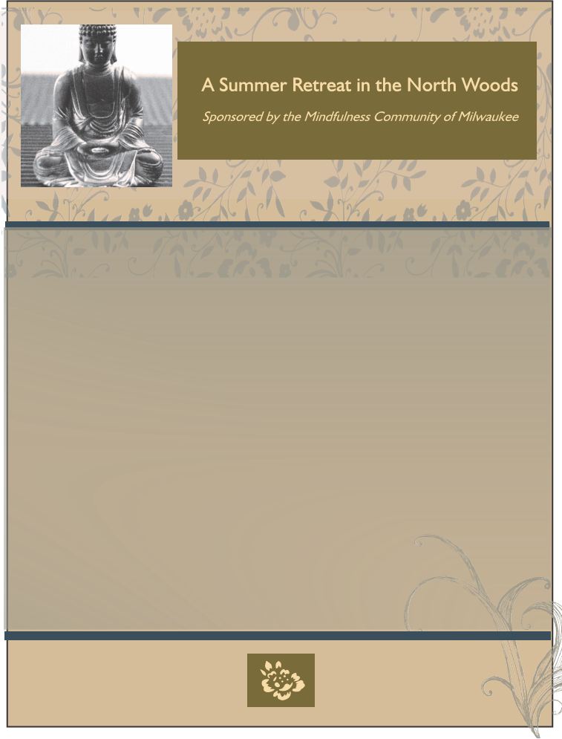
The Path of Liberation
). It is about two hours from
) or at the Christine Center’s site.
__

The Four Noble Truths

The dates of this retreat are from the evening of Sunday, August 2 (dinner will be served at

5:00 pm and retreat proper starts at 7:00 pm) through the afternoon of Friday, August 7,

2020 (after lunch, 1:30 pm), at the Christine Center, Willard, Wisconsin. The members of

the Mindfulness Community of Milwaukee are happy to provide this retreat. We are all

practitioners in the tradition of the Vietnamese monk, Thich Nhat Hanh. The retreat will

follow formats similar to ones that Thich Nhat Hanh has led previously. There will be time

for meditation, dharma talks, discussion groups, as well as bodywork and outdoor

walking.

The Christine Center is a beautiful spiritual retreat nestled in the north woods. For

information, see their website (www.christinecenter.org

Green Bay, three hours from Madison or Minneapolis, or four hours from Milwaukee. For

directions, you may look at “Driving-to-the-Christine-Center” on our website

(www.milwaukeemindfulness.org

The price for the retreat is $310 to $525, depending on the accommodations, and includes

all meals. For more information or to register, please contact the Mindfulness Community

of Milwaukee, 1922 East Park Pl., Milwaukee, WI 53211. For retreat information or

questions, email: retreatinfo@milwaukeemindfulness.com.








ACCOMODATIONS: (all including bedding and towels, except campers)

2 to 4 person occupancy (so perhaps consider roommates)

Modern Hermitage: bath with shower, kitchenette, heat, AC - $525

Guest House/Shekinah: rooms with private bath, skylight, mostly in the center - $475

Rustic Hermitage: comfortable, heat, portable toilets (shower at modern facility on campus) - $425

Camping (with electricity) - $340

Camping - $310

Name _________________________________________________________________________

Address _______________________________________________________________________

Email__________________________________________________________________________

Type of Accommodation ________________________________________________________

Preferred Roommate(s) __________________________________________________________

Dietary Needs __________________________________________________________________

You may pay half now to reserve a spot. Full payment expected by July 1.

Payment ___________________________

Fund for scholarships ___________________________

Total ___________________________

Note: Scholarships are available!

Pay to:

Mindfulness Community of Milwaukee

Mail to:

Retreat Registration

Mindfulness Community of Milwaukee

1922 E. Park Place

Milwaukee, Wisconsin 53211

Or you may also pay online (see our website www.milwaukeemindfulness.com/shop)

